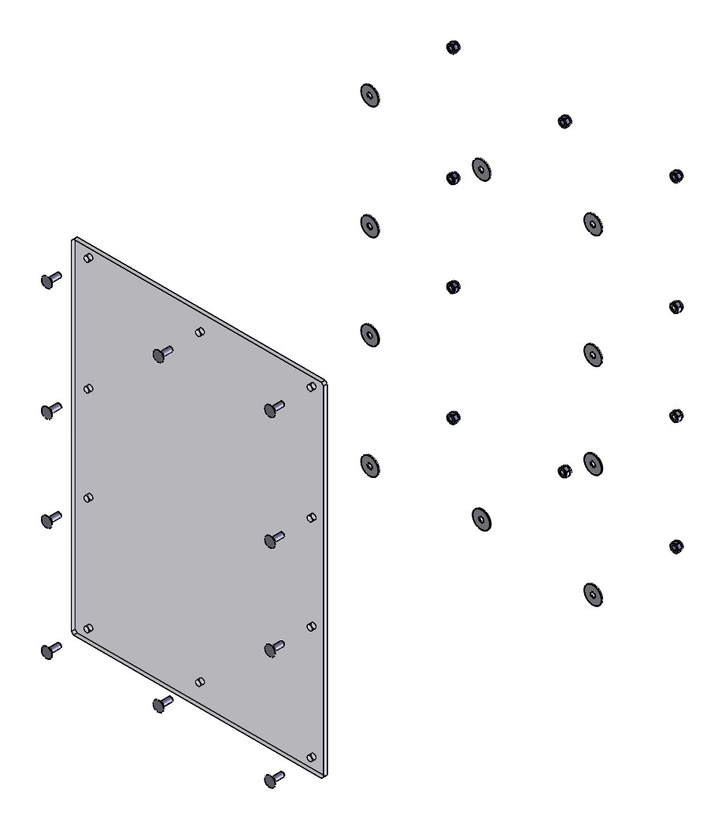
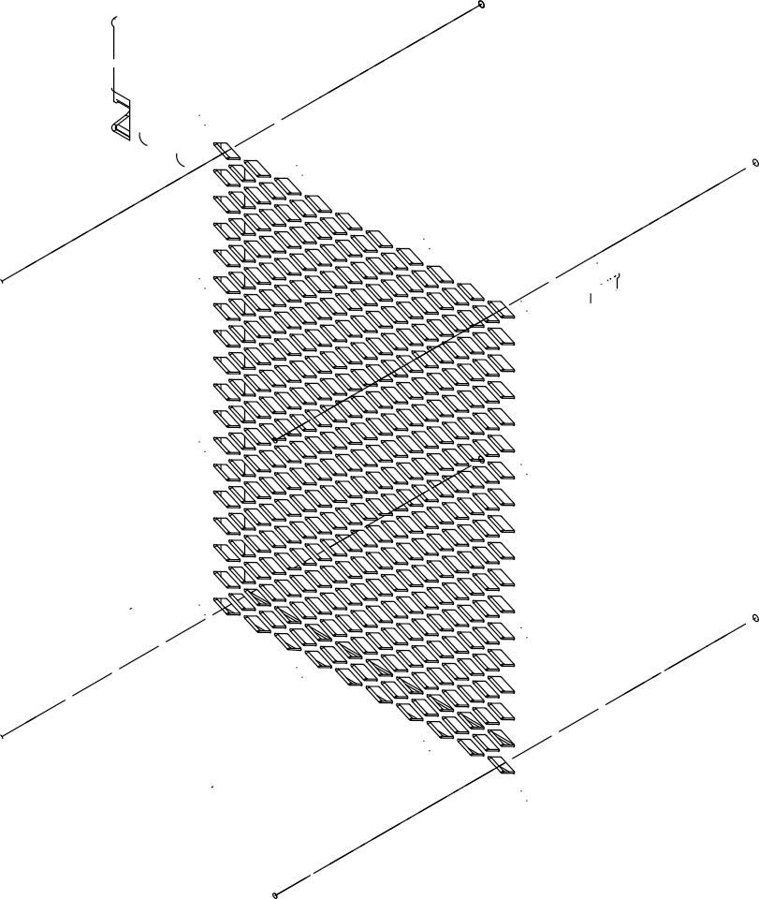
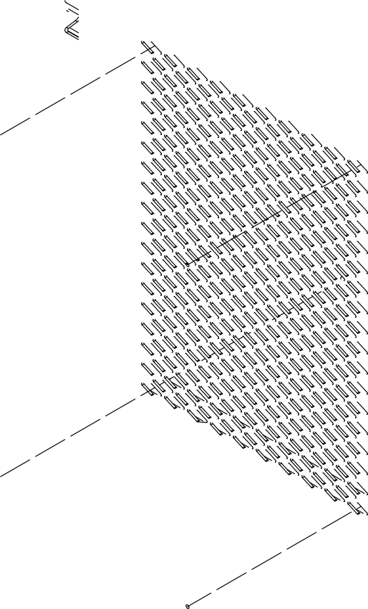
INSTALLATION INSTRUCTIONS

ALUMINUM PLATE

ANY DOOR OR EXIT HATCH

1. INSTALL THE ALUMINUM PLATE FROM INSIDE OF THE KIT.
2. ALIGN ALL MOUNTING HOLES AND USE THE SUPPLIED HARDWARE; CARRIAGE BOLTS, WASHER AND NUTS TO SECURE IT IN PLACE.
3. ALL NUTS SHOULD BE INSTALLED AT OPPOSITE SIDE OF THE ALUMINUM PLATE.

NUT

WASHER

TITLE:
HAVIS, INC.
75 JACKSONVILLE RD, WARMINSTER, PA. 18974
1-800-524-9900

INSTALL INSTRUCTION

CARRIAGE BOLT

SIZE
A
DO NOT SCALE DRAWING
DWG. NO.
PT-A-922-INST

REV
10/22
WEIGHT (LB): 21.88 SCALE: 1:8 SHEET 1 OF 1

